PIRELLI TYRE ORDER
ERC RALLY LIEPAJA 2014

TEAM/DRIVER _________________________________________________________

CONTACTS _________________________________________________________

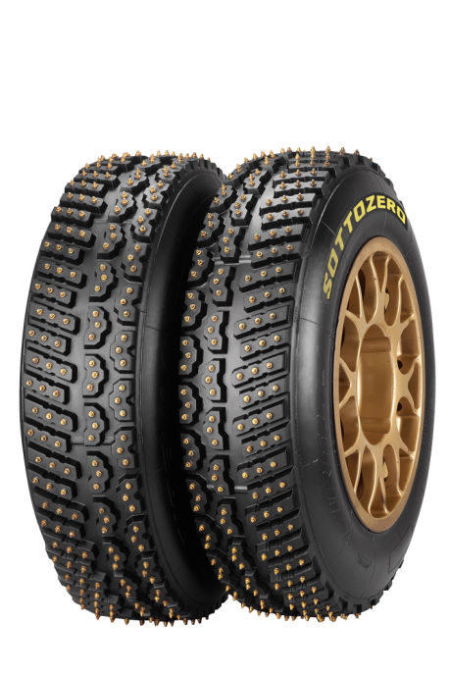

TYRE | SIZE | PRICE | QTY
SOTTOZERO ICE LEFT | 205/65R15 | 340.00 €
SOTTOZERO ICE RIGHT | 205/65R15 | 340.00 €
 |  | Price w/o VAT

This studded tyre is designed exclusively for WRC & ERC, and is meant for snowy and icy stages. The 380 studs ensure high grip even in the most severe Scandinavian conditions. The tyre benefits from Pirelli’s patented stud retention technology, where the compound design is specifically engineered to prevent the loss of studs during the stage.

Collect in service park _________ (extra charge might be applied for fitting)

Delivery to address ________________________________________________

Please send completed form to sport@latakko.lv

For more information please contact:

Girts Lagzdins
SIA Latakko
M.Nometnu str 33, Riga, LV -1002
Tel.: +371 67805238
Mob: +371 27833354

