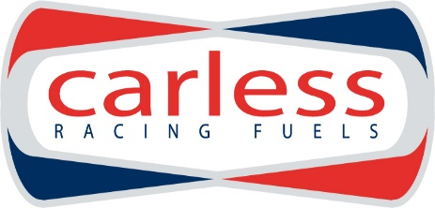
FUEL ORDER FORM FOR ERC LIEPAJA
Fuel Type | Can size | Liters required
Hiperflo Turbo Ultimate  DEV2 | 54 liter
Hiperflo WRC Gasoline 1 | 25 liter
Hiperflo 300 | 25 liter

Invoice details:
Company Name
Address

Country
VAT Registration

How to order:

Please complete the order form and send to polar.motorsport@pp.inet.fi . We will then confirm the order and send you an invoice for the fuel. Payment must be made by the latest one week before the event.
Please note that Hiperflo WRC and Hiperflo 300 fuel needs to be ordered by January 10th latest to guarantee supply.

All our fuels comply with the FIA Appendix J 2014 fuel regulations.
Ordered fuel will be available at the event the day before shakedown
CONTACT DETAILS
Name
email

Prices for the fuel delivered to the event are:
Turbo Ultimate  DEV2 | 4.15 € / L
WRC Gasoline | 5.45€ / L
Hiperflo 300 | 3.90 € / L

Please note that all prices are without VAT.
VAT @ 20% (Estonian VAT) will apply to the following:
All Estonian registered companies
All companies outside of the EU
Any EU companies not having a valid VAT code
Private individuals.

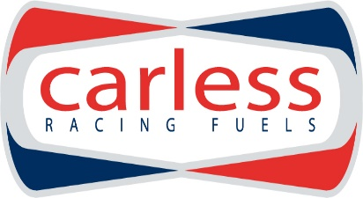

PolarMotorSport OÜ
Roosikrantsi 2-K177
10119 Tallinn, Estonia
email : polar.motorsport@pp.inet.fi
tel: +358 400 692102

