CARLESS Fuel order form
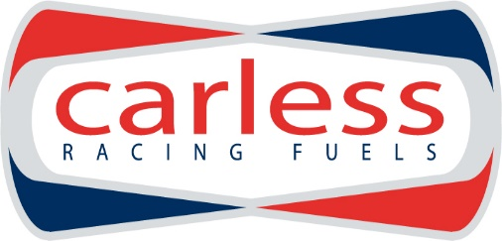
FUEL ORDER FORM FOR FIA ERC RALLY LIEPĀJA 2016
Fuel Type | Can size | Liters required
Hiperflo Turbo Ultimate  DEV2 | 54 liter
Hiperflo 300 | 25 liter

INVOICE DETAILS:
Company name
Address
Country
VAT Registration No.

HOW TO ORDER:
Please complete the order form and send to polar.motorsport@pp.inet.fi. We will then confirm the order and send you an invoice for the fuel. Payment must be made by the latest one week before the event.
Please note that Hiperflo 300 fuel needs to be ordered by January 10th latest to guarantee supply.
All our fuels comply with the FIA Appendix J 2014 fuel regulations.
Ordered fuel will be available at the event the day before shakedown.
INVOICE DETAILS:
Name
E-mail

PRICES FOR THE FUEL DELIVERED TO THE EVENT ARE:
Turbo Ultimate  DEV2 | 4.20 € / L
Hiperflo 300 | 3.90 € / L

Please note that all prices are without VAT.
VAT @ 20% (Estonian VAT) will apply to the following:
All Estonian registered companies;
All companies outside of the EU;
Any EU companies not having a valid VAT code;
Private individuals.

PolarMotorSport OÜ
Roosikrantsi 2-K177
10119 Tallinn, Estonia
E-mail: polar.motorsport@pp.inet.fi
Tel: +358 400 692102

